Waabanong Weekly Update
Delivered June 8, 2026
Week of June 1 to 5, 2026
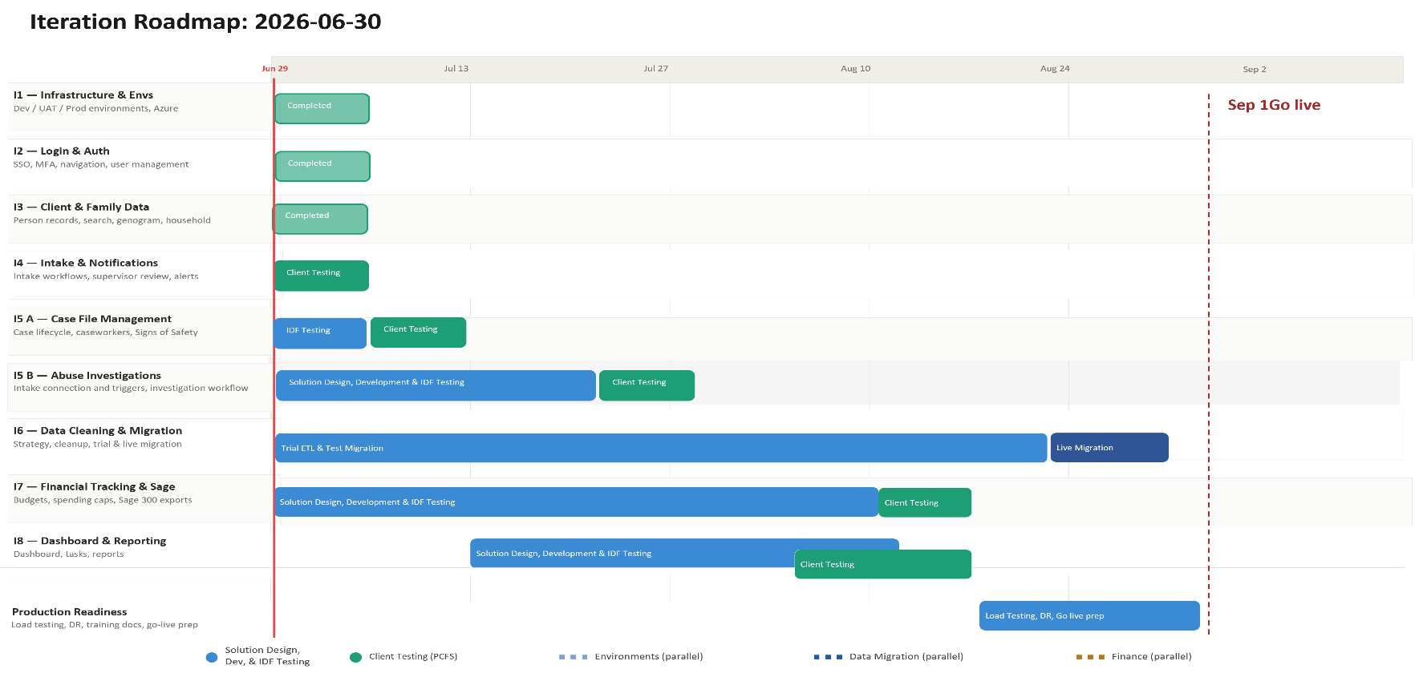

Iteration | Status | Current phase | Notes
I1 - System Infrastructure & Environments | Complete | Maintenance | Two version bumps to support rolling releases
I2 - Login & Authorization | Complete | Bug Fix | Role/permission refactor; session timeout fix
I3 - Client, Member & Family Data | Complete | Bug Fix | Genogram, marital status, and profile display fixes
I4 - Intake Management & Automated Notifications | Complete | Bug Fix | Document upload fixes; Persons Involved display fix
I5 A - Case File Management & Signs of Safety | In Progress | Development | Case file creation, documents, and placements now working
I5 B – Abuse Investigations | Not Started | — | No activity this week
I6 - Data Migration | Not Started | — | No activity this week
I7 - Financial Tracking & Exports for Sage | In Progress | Design | No activity this week
I8 - My Dashboard & Reporting | Not Started | — | No activity this week

Project Management & General
Weekly Progress
- Heavy backend development week — 45+ commits Jun 1–5, primarily building out core case file functionality (creation, documents, placements, persons involved) ahead of the following week's Signs of Safety design session with PCFS
- No client meetings this week — internal development sprint
I1 - System Infrastructure & Environments
Features
- Set up Development, Testing, and Production environments
Weekly Progress
- Two version bumps to support rolling releases
I2 - Login & Authorization
Features
- Microsoft 365–based authentication
- User login
Weekly Progress
- Session timeout now correctly forces a relogin
- Role handling refactored in UserController; grouped role options implemented
- Permission model and permission UI updates
- User role validation refactored in the EntraAuthController callback method
I3 - Client, Member & Family Data
Features
- Centralized person records (children, adults, limited profiles)
  - Duplicate prevention
- Family and household structures
  - Multi-generation relationships
- Reciprocal relationship logic
- Global search across people and families
Weekly Progress
- Fixed "Do Not Contact / Other Order" incorrectly appearing in genogram
- Fixed contact name appearing twice when no preferred name is set; preferred name replaced with first/last name in Intake Persons Involved
- Added "Widow" to marital status options
- Fixed info icon visibility on limited profile avatars
- Referral source name handling updated to correctly split legal name parts for limited profiles
- Fixed Primary Caregiver badge display delay
- Moved show/hide icon outside the LGBTQ dropdown for clarity
- New profile-type icon now shown on new records
I4 - Intake Management & Automated Notifications
Features
- Structured intake workflows with mandatory fields
- Intake status tracking and lifecycle
- Supervisor review and approval processes
- Ability to resolve intake without opening a case
- Escalation from intake to case creation
- Printable intake records
- Automated notifications:
  - In-application alerts
  - Defined external channels (email/messaging)
Weekly Progress
- Intake document upload implementation and fixes
- Original filename now displayed for attached documents in intake forms
- Fixed Persons Involved section incorrectly showing preferred name
I5 A - Case File Management & Signs of Safety
Features
- Case file creation and lifecycle management
- Assignment of caseworkers and supervisors
- Case reassignment with approval
- Signs of Safety–aligned workflows, including:
  - Placement
  - Structured assessments
  - Safety goals and planning
  - Ongoing review checkpoints
- Visibility into historical and related cases
- Case notes for visits, services, and interactions
- Communication tracking across intake and case contexts
  - Document management: Person, Intake & Case
Weekly Progress
- Case file creation now working end-to-end
- Case file header and file upload implemented
- Case file documents tab added, with placeholders for remaining tabs
- Overview tab: "At a Glance" section now static except for the Open Task card and New Task Assignment modal
- Persons Involved section implemented for case files
- Fixed the director selection dropdown
- Added `assigned_director_id` to case files, with cascading updates when a supervisor is reassigned
- Resource homes added, supporting placement type selection
- Placement functionality in progress
- Fixed No Contact Order (NCO) expiry date not displaying
- Removed the active-case-file check/modal; New Case button now respects role restrictions
I5 B – Abuse Investigations
Features
- Triggers and integration with Intake module
- Investigation workflow
- Investigation document management

Weekly Progress
- No additional external review this week; Abuse Investigations remains in solution design, incorporating PCFS workflows.

I6 - Data Cleaning and Migration
Features
- Develop a data migration strategy from FAMCare into Waabanong
- Support PCFS as they perform data cleanup
- Execute trial data migrations in a sandbox environment
- Perform live data migration
Weekly Progress
- No activity this week.
I7 - Financial Tracking & Exports for Sage
Features (Potential scope may include)
- Intake-level emergency supports
- Case-level budgets
- Spending caps and approvals
- Export files to import into Sage 300
Weekly Progress
- No activity this week.
I8 - My Dashboard & Reporting
Features (Potential scope may include)
- My Dashboard (simple, quick reference to key items)
- Tasks & alerts
- Reporting (if required and not covered in other iterations)
Weekly Progress
- No activity this week.

